

**Software Requirements**

**Specification**

**for**

**Fuel Management System**

**Version 1.0 approved**

**Prepared by Parth Teraiya**

**Dharvi Kotak**

**Dharm Bhut**

**Devyani Jagad**

**RK University**

**Table of Contents**

**Table of Contents ii**

**Revision History ii**

**1. Introduction 1**

1.1 Purpose 1

1.2 Document Conventions 1

1.3 Intended Audience and Reading Suggestions 1

1.4 Project Scope 1

1.5 References 1

**2. Overall Description 2**

2.1 Product Perspective 2

2.2 Product Features 2

2.3 User Classes and Characteristics 2

2.4 Operating Environment 2

2.5 Design and Implementation Constraints 2

2.6 User Documentation 2

2.7 Assumptions and Dependencies 3

**3. System Features 3**

3.1 System Feature 1 3

**4. External Interface Requirements 4**

4.1 User Interfaces 4

4.2 Hardware Interfaces 4

4.3 Software Interfaces 4

4.4 Communications Interfaces 4

**5. Other Non-functional Requirements 5**

5.1 Performance Requirements 5

5.2 Safety Requirements 5

5.3 Security Requirements 5

5.4 Software Quality Attributes 5

**6. Other Requirements 5**

**Appendix A: Glossary 5**

**Appendix B: Analysis Models 6**

**Appendix C: Issues List 6**

# Revision History

|  |  |  |  |
| --- | --- | --- | --- |
| **Name** | **Date** | **Reason For Changes** | **Version** |
|  |  |  |  |
|  |  |  |  |

# Introduction

## Purpose

The purpose of this SRS document is to verify software requirements of the Online Fuel Management. It is intended to be a complete specification of what functionality the system provides. The main purpose system to automate the process of refueling vehicle. Specific design and implementation details will be specified in a future document.

## Document Conventions

This Document was created based on the IEEE template for System Requirement

Specification Documents.

Main heading: Times New Roman, 18 size, Bold

## Intended Audience and Reading Suggestions

The developed SRS is intended for the development team which includes the developers, the

documentation writer, the designer and under the Guidance of Experts.

## Product Scope

This product’s aim is to automate the system. Calculating the total fuel, average of vehicle, total fare,

Collecting all necessary information of the users and then serve the user. The data used by the system is stored in a database that will be the center of all information held users and employees and the base for the reminders of the process after the initial application has been made. This enables things to be simplified and considerably quickened, making the jobs of the people involved easier. It supports the current process but centralizes it and makes it possible for decision to be made earlier and easier way.

## References

[**https://www.reqview.com/doc/iso-iec-ieee-29148-srs-example/**](https://www.reqview.com/doc/iso-iec-ieee-29148-srs-example/)

# Overall Description

## Product Functions

This section provides the graspable functional overview of the end product. The product is

expected to be providing following functionalities

1. Login

2. Register

3. Dashboard

4. Driver Details

5. Settings

6. View Profile

7. Change Password

8. Refuelling

## User Classes and Characteristics

In This Refuelling management system user can add fuel records Their App but for that user has to first register with unique Email/Driver licence number and password after that user can successfully get login in the dashboard and then User can add fuel details, after login the application user can also change their profile picture, Update password and can perform many other activities.

## Design and Implementation Constraints

Database used: SQL

The system is developed in Android Studio and is supposed to work on an Android Mobiles

Android version should be 6 or above.

## Assumptions and Dependencies

The users must login to their accounts by the email they registered with in the registration page

If not registered, then first must register in the application. The user will to enter a valid details and then the details will show in owner mobile.

# System Features

## System Feature 1

### **Login and Registration**

It has the highest priority in the application. Without login you cannot access any page of the Application and you cannot login the app without registration, so users have to compulsory register with their Valid Email id before using the application.

### **Add New Vehicle**

### We will add new vehicle details. In one id we will enter many vehicles details.

# External Interface Requirements

## User Interface

The system provides a sophisticated platform for the user to enter their account information as to

login to their account.

If a user enters wrong account information i.e. wrong email or wrong password, an error will

pop up showing that they entered the wrong information.

If there is a new user who needs to register into the Application and wishes to become a member,

they can simply sign up.

## Hardware Interface

Various interfaces for the product could be:

1. Monitor

2. Keypad

3. Mouse

4. A connection to the entered houses database

5.Android Mobile Phones

## Communication Interface

The communications standards that will be used is GUI (Graphical user interface). This interface

must be highly intuitive or interactive because there will not be an assistance for the user who is

operating the system.

Here one user will enter fuelling details and owner have a get notification.

The interface is designed to be very user-friendly so anyone with a very little knowledge of the

Applications can also operate the App.

Also, the password should be private, this can be by using asterisks at the password panel

# Other Nonfunctional Requirements

# Performance Requirement

● Increase customer satisfaction.

● Application must allow customers to access adding details services 24 hours a day.

● Reduce overall costs

# Safety Requirement

● Backup, recovery and business continuity Fuel Details should ensure adequate backup of

data as may be required by their operations.

● Both data and software should be backed up periodically.

● An off-site backup is necessary for recovery from major failure to ensure business continuity.

* 1. **Security Requirement**

The user will enter his information and he can change it and the owner can check the user details.

1. **Other Requirements**

**Appendix A: Glossary**

*GUI: Graphical user interface*

**Appendix B: Analysis Models**

**Class Diagram**

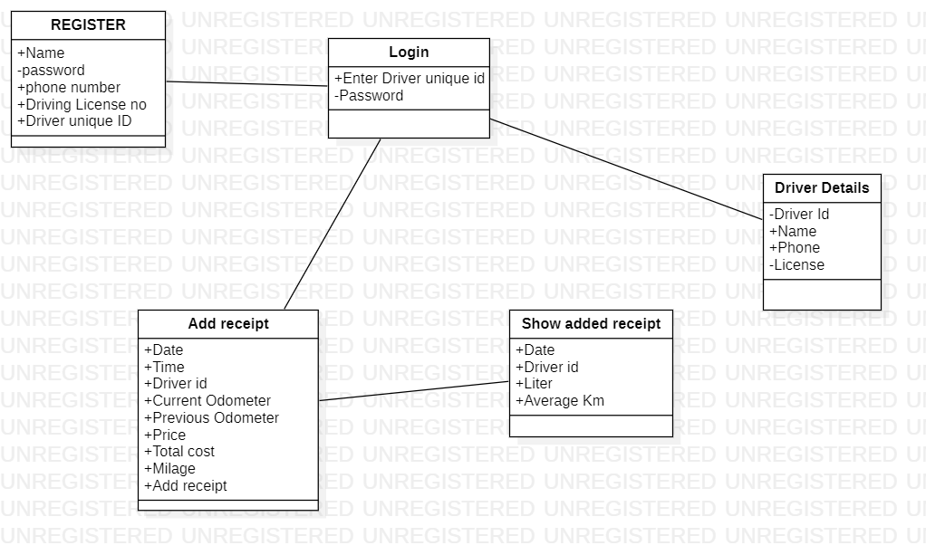

**Flow chart**

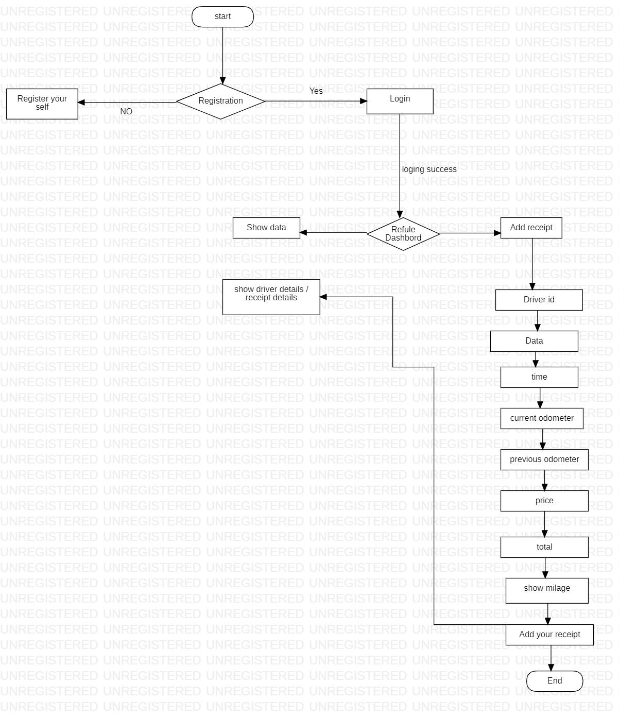

**Activity diagram**

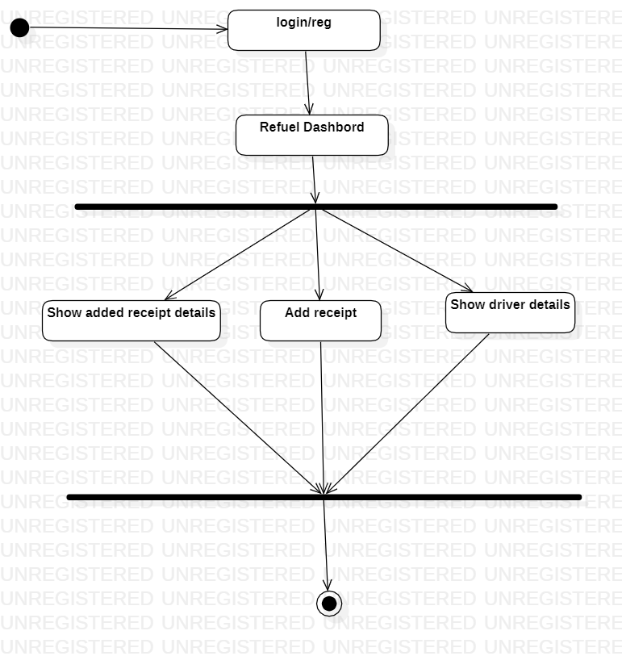

**DFD (Data Flow Diagram)**

***Level-0***

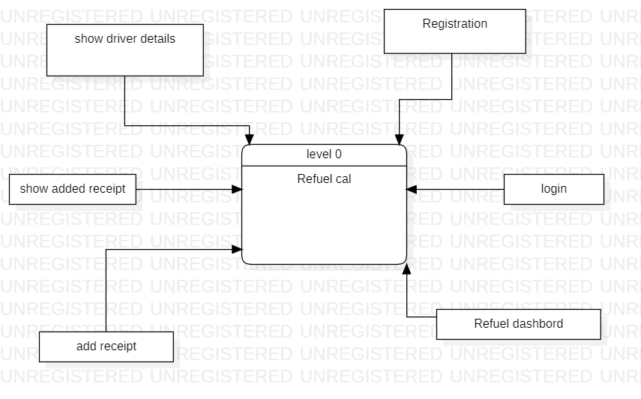

***Level-1***

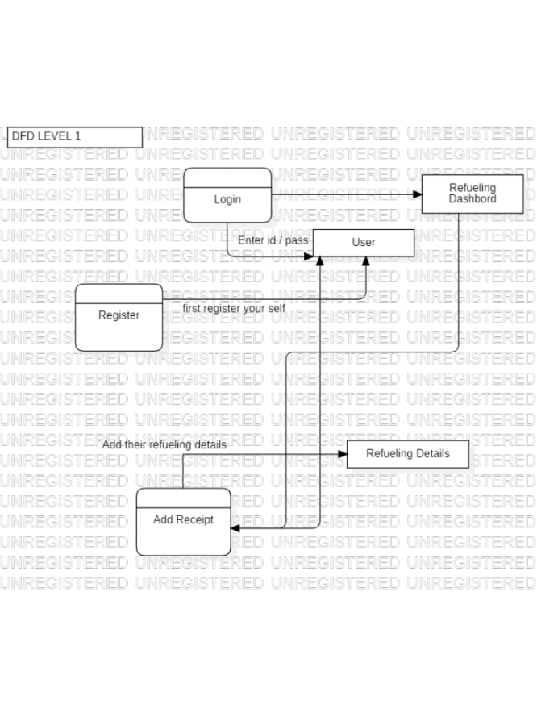

***Level-2***

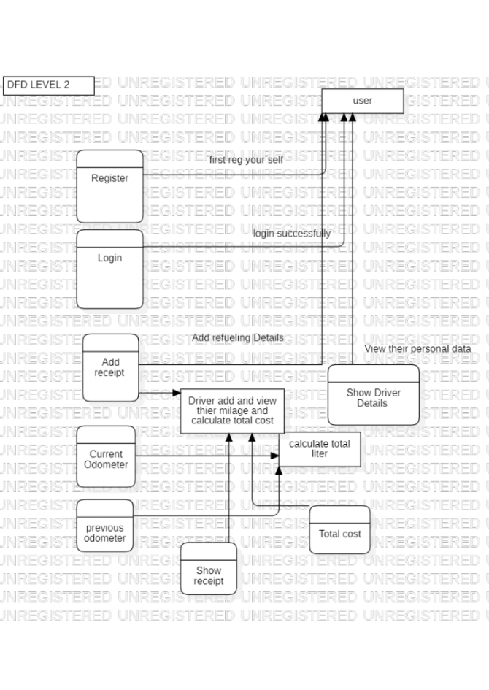

***Use-Case Diagram***

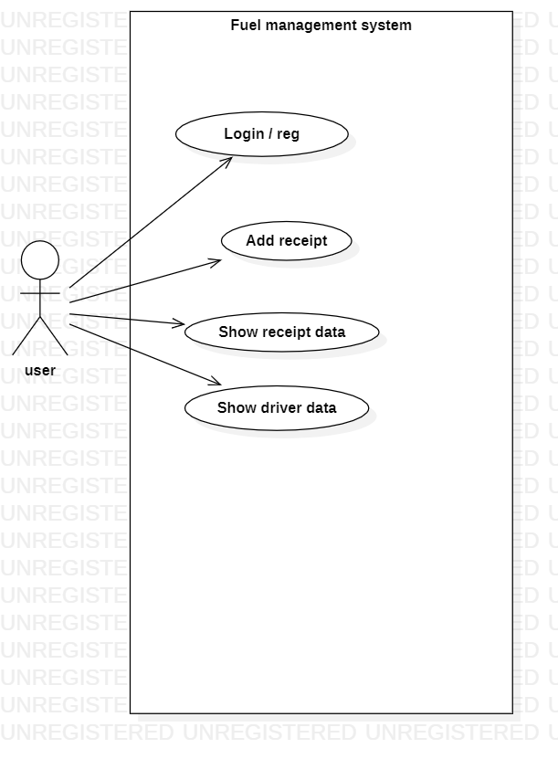

**Appendix C: Issues List**

* *Take some time to enter fuel data.*
* *Login when enter new record.*
* *Network/Internet issue****.***

***Wireframes***

